BEST HELPDESK TICKET & HOT HANDOFF PROCEDURE

Originator: | James Vaughn | Effective Date: | Draft v1.2
Revised by: | James Vaughn | Revision Date: | 06/28/2019
Manager: | Johan Madrigal | Previous Rev: | 05/07/2019
Approval: |  | Procedure #: | HD0030

Overview

This document covers the procedures for responding to calls and emails to the Help Desk by both internal and external (school district) BEST Advantage System users needing support with accessing and using the BEST applications and training resources. This guide does not cover routing of technical issues such as BEST-related network, server, or Web site/application programming issues. For these issues refer to HD0032, Identifying and Routing BEST Technical Issues (still in development).

BEST Advantage Systems Overview
Business Enhancement System Transformation (BEST) is a replacement for LACOE’s legacy PeopleSoft and HR systems. Like those systems, it will be used not only internally but also offered as a service to school districts. The main goal of the BEST Project is to have an integrated Enterprise Resource Planning System for budget development, finance, human resources, and payroll. Hence, it is comprised of three main systems: Budget (BUD), Finance (FIN), and Human Capital Management (HCM). Starting with BUD, these services are being rolled out to the districts in “Waves” with a gradual phase in of FIN and HCM as well as a gradual increase in the number of districts brought onboard. More information about the project milestones and progress is available at the BEST Project Customer Resource Center (https://bestcrc.lacoe.edu/). The main point of entry for any BEST application or training resource is the BEST Portal at https://bestportal.lacoe.edu.
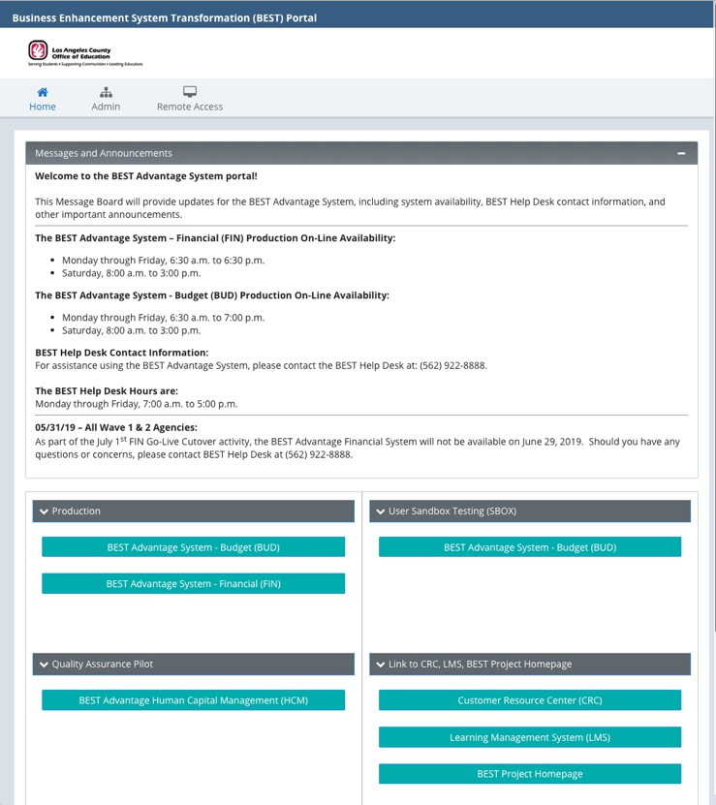

Help Desk Support Role
The Help Desk is to be the first point of contact for BEST support for both district and internal staff. BEST users are directed to call the BEST Help Desk at (562) 922-8888. Calls from this number are identified as BEST calls in the Help Desk phone system and the Help Desk technician is to identify him or herself as a BEST System Support technician.
Upon receiving a call for support, the Help Desk technician must interview the client and attempt to identify whether the issue is with using the BEST application itself or caused by a technical problem such as a network, server, or desktop client issue. Issues with using the application could be user authentication issues (Security), problems with how to perform tasks within the applications (Functionality), programming bugs or issues accessing the Web site (Technical) or problems with accessing and using training resources (Training). Once the issue has been identified, a ticket is created and assigned to the appropriate BEST support queue.
If the issue involves Functionality or Training, the technician will then place the client on hold and attempt to contact the first of three designated BEST Subject Matter Expert (SME) resources assigned to the routed queue. (See the BEST HD Quick Route Guide for a list of resources for each support group1). If a SME is available, the technician provides the SME with the client’s name, district, basic issue, and Remedyforce ticket number and then transfers the client to the SME. This procedure is referred to as a “hot handoff.”
If no SME is available, the technician will inform users that a support ticket has been created and they can expect a return call from a support technician within 24 hours. Since an automated email from Remedyforce was sent to the assigned support queue’s group email account upon ticket creation, no further action by the Help Desk technician is necessary. For all other issues, no hot handoff is necessary; however, critical issues such as outages will require immediate escalation and notification to the appropriate support groups.

Determining Ticket Routing
Routing will be determined during the client interview. After gathering the user’s name, school district, and contact information, proceed with the following questions:
- What system are you accessing? Choices are BUD, FIN, HCM, or Training Sites (LMS or CRC). If FIN, you will also need to ask which application the client is using (Accounts Payable, Accounts Receivable, Budgeting, Fixed Assets, General Ledger, Inventory Management, or Procurement).
- What is the issue you are having? Issues will fall under these major categories: Security/Workflow, Functionality, Training, Technical. Refer to the BEST HD Quick Route Guide to identify the major issue group that handles each issue. The guide has separate pages for FIN and BUD; HCM will be added when it goes into production.
- General guidelines:
  - Security and Workflow - Login or password issues generally fall under Security/Workflow. However, issues with logging into the LMS or CRC training sites are handled by the Training group.
  - Functionality - Issues with using the BEST applications themselves are called functional issues and are handled by the Functionality group.
  - Training - Issues with registering for or cancelling classes, checking class schedules, or using the CRC or LMS websites are handled by the Training group. You will need to find out if the training issue is for BUD, FIN, or HCM when creating the ticket.

1 The BEST HD Quick Route Guide can be accessed from the Help Desk Teams site by going to the Files list in the BEST Support channel.

  - Technical – Programming bugs within an application, site down, slow performance or Web site errors are handled by either AD&S or TIS depending on the issue. Since it may be difficult to determine the underlying cause of a particular issue, consult with a Help Desk lead or senior staff if you are unsure how to route the ticket. You may also refer to Help Desk document HD0032, Identifying and Routing BEST Technical Issues, once it becomes available.

BEST Ticket Procedure Step-by-Step – District User
- When a call comes in from the BEST Help Desk support number, (562) 922-8888, the technician should answer as follows, “BEST System support, <Name> speaking. How may I help you today?” Do not identify as a LACOE Help Desk technician.
- Initiate a Remedyforce ticket (See HD0004, Remedyforce Opening Incident –Note this document is out- of-date) and begin interviewing the client to obtain the following required information:
  - Full name
  - School district (non-LACOE) or work location (LACOE)
  - Best contact phone number
  - Email address
This information should be entered into the ticket as you are conducting the interview. Remedy tickets are divided into 6 sections. However, there are only 3 to be concerned with when creating a ticket: Client Details, General Service Request Information, and Service Request Details. The steps to enter client details are different for school district clients and internal employees as noted in the next two steps.

The Client Details Section – District Users
  - In the Client ID field, enter “District User.”
  - In the Client Note field, enter the client’s best contact phone number and email address.
  - In the Select School or Site field, enter the name of the client’s school district. Do not enter an individual school site—this must be the school district name.
  - In the Business Area field, drop down the list and pick the closest business area that matches the client’s department.
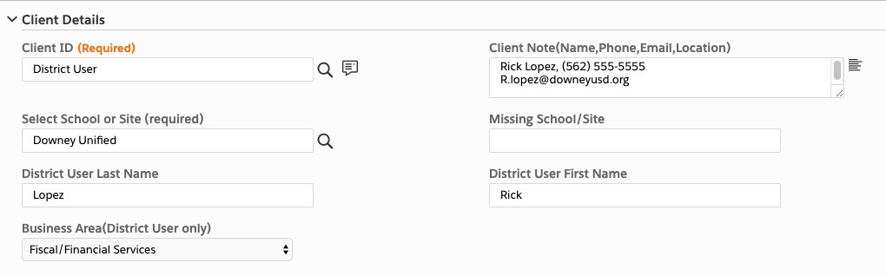
Figure 1: The Client Details Section

The Client Details Section – LACOE Users
  - In the Client ID field, choose the client’s name from the list of available employees. If the employee is not found, enter the employee’s supervisor’s name as listed in the LACOE organizational chart at

https://orgchart.lacoe.edu. In the Client Note field, type “Client not found in Remedy:” and then fill in the actual client’s contact info as noted in the next step.
  - In the Client Note field, enter the client’s full name, best contact phone number and other up-to-date contact information as needed.
  - In the Select School or Site field, enter the name of the client’s work location. Skip the remaining fields in the Client Details Section.
- The General Service Request Information Section – There are three options under the Request Definition
field for BEST-related issues:
- BEST ADS Application and Request – For application program errors or Web site errors that prevent access or contribute to slow system performance.
- BEST Application Issue and Request – For user authentication issues, questions regarding performing tasks within the applications, training questions, minor computer/browser configuration issues preventing login, printing, etc.
- BEST TIS Applications – For network or server related outages or performance issues.
This guide covers issues with using the applications or authentication issues that prevent the user from logging in. It assumes that the systems are up and running and accessible for users with valid user account credentials. BEST-related network, server, or Web site/application programming issues are referred to as technical issues and are covered under Help Desk document HD0032, Identifying and Routing BEST Technical Issues (still in development).
- Enter “BEST Application Issue and Request” in the Request Definition field. Skip the rest of the fields in this section and the next three sections. The required fields in these sections will be auto-populated depending on the choices made in the last section, the Service Request Details Section.

The Service Request Details Section
  - In the Applications field choose the application for the BEST system being accessed: BUD, FIN, or HCM. If the issue is training related, choose the application on which the user is currently being trained. Knowing the specific URL for the system being accessed may help identify the system when the client is unsure. You may use the chart below as a guide:

Site URL Application
https://bestportal.lacoe.edu | BUD, FIN, HCM
https://bestcrc.lacoe.edu/ | Customer Resource Center
http://best-lms.lacoe.edu/ | Learning Management System
https://best-web.lacoe.edu/pbprd01/... | BUD Prod Env login page
https://best-web-uat.lacoe.edu/BUDUAT | BUD Test Env (Non-prod) login page
https://best-web.lacoe.edu/HRMPRD01/Advantage | HCM login page
Note: If FIN is chosen, an additional field appears to select whether it is for the Prod (production) or
QA (quality assurance pilot) environment. Always choose Prod unless instructed otherwise.
  - Continue to interview the client to clarify which of five BEST support groups (listed by queues in Remedyforce) should be assigned the ticket. The following chart may help determine the appropriate group:

Major Issue Group Description/Examples
Functionality | How to use the application; problems within the application
Security/Workflow | Problems with application access; user accounts & password issues
Technical | No longer used—now determined by initial Request Definition selection
Training | Access for LMS & CRC sites; class enrollment; cancellations

Other | Not in the above; unclassifiable; research needed
In the field for major issue group, choose the major issue group that handles the type of issue identified during the client interview.
Note: The BEST HD Quick Route Guide, available on the Help Desk SharePoint site, provides more in- depth guidance to help determine the appropriate group.
  - If the application is FIN and the Functionality major issue group is selected, an additional field appears to select one of seven FIN Functionality applications. Use the chart below to aid in selecting the right application:

FIN Functional App Keywords/Functions
Accounts Payable | Payment, freight charge, use tax, ACH/EFT payment, withholding
Accounts Receivable | Create invoice, balance inquiry, customer aging report
Budget Control | Activate/inactivate account strings, budget transfers and overrides
Fixed Assets | Fixed asset entries, asset costs, asset transfers, asset location
General Ledger | Journal voucher, expenditure/revenue JV reclass, budget availability
Inventory Management | Stock related request, order fulfilment, inventory reports
Procurement | Requisitions/Purchase Orders (PO’s): use multiple account strings per line; change vendors; line change for price, qty, UOM, line description; cancel/delete a req or PO; fix budget errors; Check/clear pre-  encumbrances
Charter Schools | Choose this for all functional support requests; one team handles all  functionality issues for Charter schools.

  - In the Additional notes field, type a brief summary of the client’s issue. Focus on the problem; additional detail may be added as a separate note under Remedyforce’s work history notes, if needed. The following issues may be handled by the Help Desk technician:
    - Login issue? Ensure the client is logging into the correct site with the correct username and password convention for that site. If the login page is not loading, perform minor troubleshooting to determine the cause. See Help Desk document, HD0031-2019.06.10 BEST Password Support Draft_v1.1, for more detailed guidance with user authentication issues. If the issue is resolved, assign the ticket to yourself and close it.
    - Printing Issue? Make sure the browser is configured to allow pop-ups from the lacoe.edu domain. See the BEST end user guide, Chrome Settings for BEST Advantage Financial Form Printing, for more information. If the issue is resolved, assign the ticket to yourself and close it.
    - Client needs the date, time, or location of an upcoming training? Refer to the current training schedule available from the BEST CRC Web site or hosted on the Help Desk Sharepoint site. If you are able to provide the information needed, assign the ticket to yourself and close.
    - User didn’t receive LMS training class enrollment or CRC registration confirmation email? Direct the client to check their spam or junk folder. If email is found, assign the ticket to yourself and close.
    - Other known issue with documented solution? For some issues, a solution or workaround may have been provided to the Help Desk. Documented solutions will be placed in the Help Desk Teams’ BEST Support channel at Files > Known Issue Solutions-Workarounds. If a known solution resolves the issue, assign the ticket to yourself and close.
  - After completing the Service Request Details section, save the ticket. The completed Service Request Details section will look similar to the sample in figure 2 below.

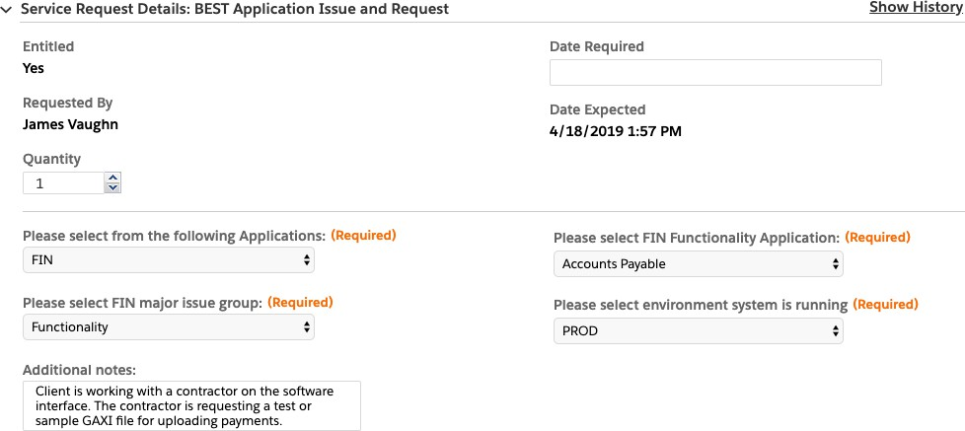
Figure 2: Service Request Details Section
  - Upon saving, some previously skipped fields listed below are auto-populated (see figure 3):
    - Ticket Type – Incident
    - Ticket Description – A concatenation of the Application Name and the Major Issue Group. For example, BUD Security/Workflow. For FIN Functionality, the application name for the functional area will also be displayed on a second line. For example, Accounts Payable.
    - Ticket Note – Populated with whatever is typed in the Additional notes field.
    - Assigned Queue – Populated with the queue that handles the major issue group selected earlier.
At the same time, Remedyforce also sends an automated email to the assigned queue’s group email account, notifying the group that a ticket has been created. The email includes the ticket number, category, description, notes and other pertinent information.
Note: For Functionality issues, only the group that supports the particular functional application selected will receive the email even though all the functional support groups are in the same queue.
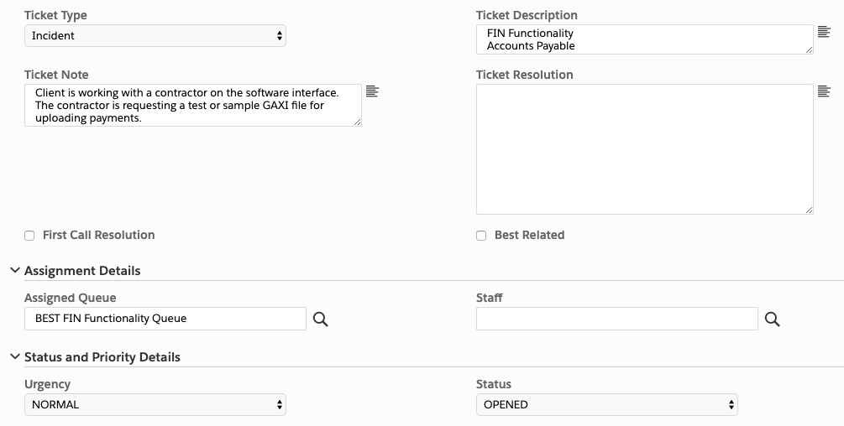
Figure 3: Auto-Populated Fields

If the issue involves Functionality or Training and was not resolved during the client interview, the Help Desk technician must attempt to perform a “hot handoff” to a designated Subject Matter Expert (SME) from the major issue group to which the ticket is assigned. The “hot handoff” is covered in the BEST Hot Handoff Procedure section below. If the issue is for Security or Technical, no further action is necessary—the automated email notification at ticket creation will suffice for these groups.

BEST Hot Handoff Procedure
The “hot handoff” is an attempt to transfer the client to an available BEST Subject Matter Expert (SME) for immediate assistance. There are three resources designated to handle calls for each group. Starting with the first resource, the Help Desk technician is to call them in order until one of them is reached. To keep the support experience uniform and professional for all clients, the following procedure for the hot handoff should be followed by all Help Desk technicians.
- Inform the client that you will be transferring them to a BEST support specialist that can handle their issue and that you will be placing them on a brief hold.
- Press the Access line button on your desk phone to place the client on hold. Using the BEST HD Quick Routing Guide, lookup the name and extension of the first Subject Matter Expert for the particular group.
- Press the Inquiry button on the phone, dial the extension, and inform the SME that you have a BEST user needing assistance. State the user’s name, school district, the basic issue, the ticket number and that you are going to transfer the call to them.
- Press the Access line button on your desk phone to return to the client. Inform them of the SME’s name and that they will be assisting the client from this point forward.
- Press the Transfer button to transfer the call. This removes you from the call and completes the hot handoff procedure.

